Economics Final Review 1

Key Terms-
Microeconomics-

Macroeconomics-

Entrepreneur-

Allocate-

Scarcity-

Division of Labor-

Barter-

Utility-

Competition-

Demand-

Diminishing Marginal Utility-

Elastic Demand-

Supply-

Profit-

Subsidies-

Productivity-

Law of Diminishing Returns-

Surplus & Shortage-

Price Floor & Price Ceiling-

Big Concepts and Things to Remember:
1. Factors of Production:
A. Natural Resources
B. Human Resources
C. Capital Resources
D. Entrepreneurship

2. Types of Economic Systems:
A. Traditional-

B. Command-

C. Market Economy-

D. Mixed Economy- Communism, Capitalism, Democratic Socialism

3. Why does the US have a Free Market System

4. U.S. Economic Goals:

5. Demand and Supply Curve

6. Determinants of Demand:

7. Determinants of Supply:

8. Costs of Production-

Economics Final Review 2

Key Terms-
Monopoly-

Cartel-

Patent-

Trust-

Laissez-faire-

Liability-

Stock-

Dividends-

Principle & Interest-

Merger-

Franchise-

Cooperatives-

Big Concepts and Things to Remember:
1. Types of Competition-
A. Perfect Competition-

B. Monopolistic Competition-

C. Oligopolies-

D. Monopolies- Different types?

2. How does the U.S. Regulate businesses?

3. Types of Businesses
A. Sole Proprietorship

B. Partnership-

C. Corporations-

4. How can Corporations combine?

Economics Final Review 3

Key Terms-
Intrinsic Rewards-

Affirmative Action-

Labor Union-

Collective Bargaining-

Mediation-

Arbitration-

Injunction-

Balance-

Time Deposit-

Budget-

Broker-

Credit Rating-

Bankruptcy-

Big Concepts and Things to Remember:
1. What should people look at when entering the labor force?

2. Why are labor unions important to workers?

3. Why and how can people save money?

4. Why own stocks and how are they traded?

5. What should you know about buying on credit?

6. What ways do governments raise money through taxes?

7. Where does the government spend money in their yearly budgets?

74.__ In exchange for the use of money while it is deposited, a financial institution pays the saver
- Profit
- Wages
- Interest
- Dividends
75.__ Unemployment hurts the economy as a whole because
- The nation loses the goods and services that the unemployed would produce if they were working
- Businesses lose sales because the unemployed cannot buy as many products
- To some extent, the government supports unemployed and their dependents
- All of the above
76.__ The Equal Employment Opportunity Commission makes and enforces regulations to protect workers from
- Discrimination in hiring or promotions
- Impure food and drugs
- Terrorism
- None of the above
77.__ Which of these government programs does the government by a wide margin spend the LEAST on
- Medicare and Medicaid
- Foreign aid
- Defense
- Debt
78.__ State and local governments spend money on
- Education
- Public Welfare
- Roads and maintenance
- All of the above
79.__ Communism is different from Capitalism in that
- The government controls most of the means of production
- The government has no control of the economy
- Business leaders control the market
- There are no differences
80.__ In the last 20 years, the use of automation in United States industry has led to
- a shortage of consumer goods
- increased union membership
- the lowering of the legal minimum wage
- increased unemployment among unskilled workers
"President Nixon Plans Trip to China To Meet with Chairman Mao"
"President Carter Signs New Panama Canal Treaty"
"President Clinton Concludes Trade Agreement with Japan"

81.__ These headlines since WWII showcase what important economic trend
- The US is more involved in world affairs and economies
- The US is isolating itself
- The world will not allow US involvement
- None of the above

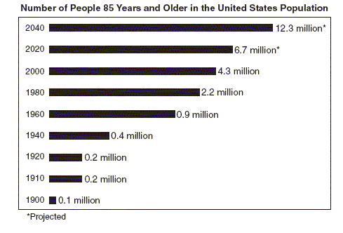
82.__ What issue does this graph showcase could be a problem in the near future?
- Spending for the elderly will increase dramatically
- Spending for the elderly will decrease dramatically
- Need for greater child care
- It shows no change for the US

83.__ The changes shown in the graph support the recent concerns of Americans about the
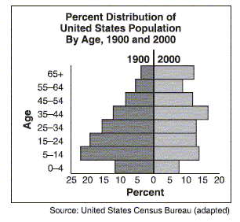
- future of Social Security and Medicare
- return to an agrarian society
- surplus of health care workers
- shortage of schools and colleges
84.__ The cartoonist is trying to encourage American consumers to consider that
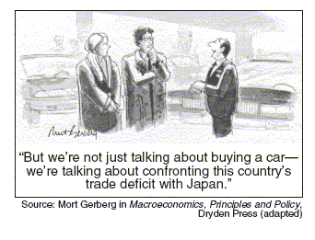
- the United States buys more from Japan than Japan buys from the United States
- cars produced in the United States are often inferior to foreign-made automobiles
- single purchases of automobiles do not have an impact on calculating foreign trade balances
- automobile dealerships in the United States should offer more incentives for purchasing American-made cars

85.__ What is the main idea of the cartoon?
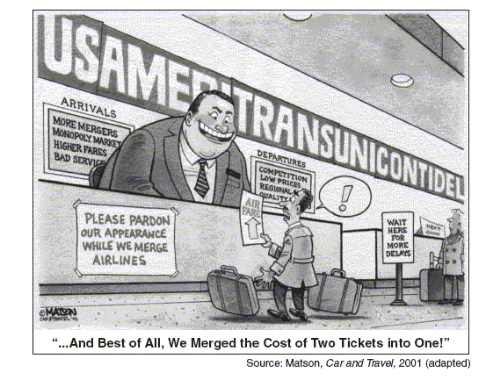
- Airline technology has resulted in more efficient service.
- Reduced competition in the airline industry has hurt the consumer.
- A growing economy has led to the start-up of new airlines.
- An increase in the number of airlines has led to computer malfunctions.
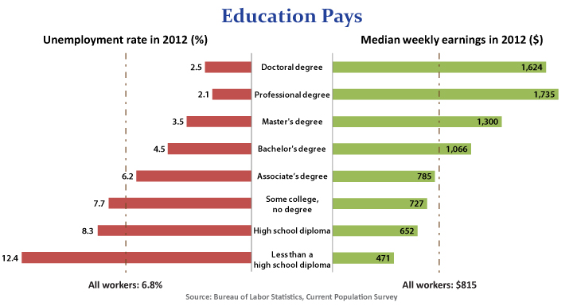
86.__ What does this graph tell the reader about education
- The level of education has no effect on unemployment or pay
- As your degree level goes up your median pay goes down
- Unemployment is unrelated to education
- More education increases pay and lessens the chance for unemployment

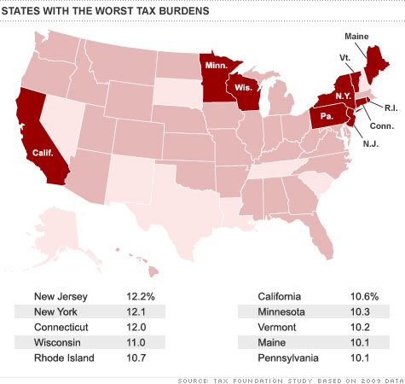
87.__ What problems can be determined from the graph above?
- All states have the same tax burden
- States with a higher tax burden may lose people and business
- States with the highest tax burdens are always safer
- Nothing can be learned from this graph
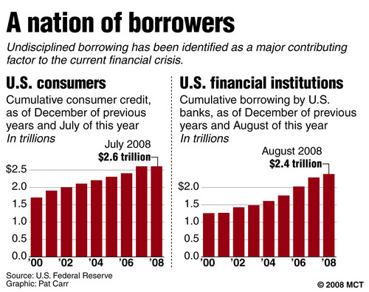
88.__ According to this graph
- Both consumers and financial institutions both borrowed increasing amounts leading up to the 2008 financial collapse
- Only consumers increasingly borrowed money leading to the 08 collapse
- Only financial institutions borrowed money leading to the 08 collapse
- Neither consumers or financial institutions increasingly borrowed money before 08

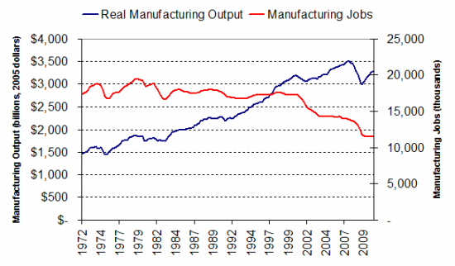

89.__ According to this graph what can be determined about manufacturing in the US
- Manufacturing jobs are increasing greatly in the US over the last 30 years
- Manufacturing output has dropped in the US over the last 30 years
- Manufacturing jobs are down but the amount of output is up in the last 30 years
- Manufacturing output is down but manufacturing jobs are up in the last 30 years
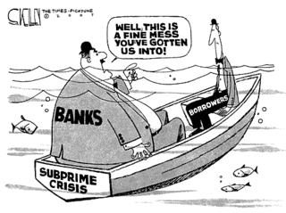
90.__ According to this cartoonist
- Banks and borrowers were equally to blame for the subprime crisis
- Only banks were to blame for the subprime crisis
- Only borrowers were to for the subprime crisis
- Banks were more to blame for the subprime crisis
44.__ Which of the following forms of business organization does not focus on financial gain for its members?
- Subsidiary
- Nonprofit organization
- Conglomerate combination
- Franchise
45.__ A job requiring high skill levels generally offers high wages because
- There is a limited supply of people with those skill levels.
- Demand for skilled workers is limited.
- Skill level is the only factor that determines wages.
- There is a surplus of skilled workers
46.__ You might find higher wages being paid for skyscraper construction because
- There is a great demand for construction workers.
- There is an ample supply of construction workers.
- It is a hazardous occupation.
- All of the above
47.__ The demand for resources derives, or follows, from consumers’ demand for
- Goods and services.
- Cheap labor.
- Marketable skills.
- Lower prices.
48.__ What can change as producers try to meet new needs and wants of consumers?
- Skill levels
- Employment patterns
- Intrinsic rewards
- Price levels
49.__ The number of woman in the labor force is
- Stable
- Fluctuating
- Increasing
- Falling

3.__ Specialization increases productivity because
- Workers gain expertise in the assigned task
- It reduces the number of workers needed
- Workers are not as tired from their task
- It increases the number of workers needed
4.__ A production possibilities curve illustrates all the
- Technological changes that help to increase production
- Choices a person can make between items
- Economic choices a society can make
- Combinations of two goods or services that can be produced
5.__ The means of exchange that relies on bargaining is
- Money
- Credit
- Utility
- Barter
6.__ The means of exchange that allows consumers to buy the product before it is fully paid is what?
- Money
- Credit
- Utility
- Barter

- Decrease in Oil production in the Middle East causes wheat prices to rise in the US
- Hurricane in the Caribbean causes rum prices to rise in Europe
- High production of corn in the US causes lower prices of rice in Asia
7.__ What economic term do these headlines help to explain?
- Interdependence
- Money
- Self-sufficiency
- Opportunity Cost
8.__ The economic system in which children are likely to have the same jobs as their parents and there are limited economic opportunities?
- Market economy
- Command economy
- Mixed economy
- Traditional economy
9.__ The economic system where the government answers most of the economic questions is what?
- Market economy
- Command economy
- Mixed economy
- Traditional economy

Characteristics of the Economy in Sweden
The Government:
• maintains a strong presence in utilities, transportation, and defense
• has partially or fully privatized many large companies and banks
• strives to increase its reliance on market forces and to reduce state ownership
10.___ Which statement explains the role of government in the Swedish economy?
A) The Swedish government maintains full control over the economy.
B) The Swedish government attempts to distribute wealth.
C) Sweden is making a transition toward a free enterprise system.
D) Sweden is increasing regulation over the private sector of the economy.

11.__ According to Adam Smith the “invisible hand” that leads individuals to do what is best for society is
- Competition
- Self-interest
- Freedom of choice
- Free enterprise
12.__ The US is an example of what type of economy?
- Democratic Socialism
- Capitalism
- Socialism
- Communism
13.__ The feature that distinguishes the US economy from a pure market economy is what?
- Private ownership of all businesses
- Contracts for individuals and businesses
- Self interest
- Limited government involvement
14.__ The things that people use to make or obtain what they need or want are called
- Products
- Resources
- Goods
- Services
15.__ During the old kingdom period, when the Pharaoh owned the land, collected taxes, controlled trade, and oversaw all building projects mean that Egypt had
- A market economy
- A mixed economy
- A command economy
- Capitalist economy
16.__ The amount of money that the consumers have available to spend on goods and services is called their
- Income effect
- Substitution effect
- Purchasing power
- Marginal power
17.__ Non-price determinants of demand include
- Consumer taste
- Consumer expectations
- Prices of related goods
- All of the above

